**INDEPENDENT STUDY REPORT**

HARSH GAJRA -B00659265

**Project Title** – Snake Game 2d in python with Graphics

**Introduction**

* Snake is the common name for a video game concept where the player maneuvers a line which grows in length, with the line itself being a primary obstacle.
* As it moves forward, it leaves a trail behind, resembling a moving snake.
* It’s a classic game which was very well known and offered on Web browsers and mobile Phones
* The game in this project has been developed in Python using ‘Pygame’ module which is a Free and Open Source python programming language library for making multimedia applications like games built on top of the excellent SDL library. Like SDL, pygame is highly portable and runs on nearly every platform and operating system.
* The scope of the project was to familiarise and understand the underlying concepts of Python programming development and also learn concepts about pygame to develop games in python with interactive graphics.

**Working:**

* The game starts with randomly spawning the snake and the food across the game window.
* The snake moves across the game window chasing the food which is spawned randomly within the window size.
* The Snake gets longer as it eats the food.
* The score is incremented by 1 as snake eats the food.
* After snake eats the food, the food is again randomly spawned within the game window.
* The snake dies and Game over is displayed on screen with Final score.
* If the snake touches itself then it dies with Game over displayed on screen with final score .
* Pygame module gives the functions necessary for rendering graphics and also setting up colours in the game.
* To develop the Game window we use the function playSurface = pygame.display.set_mode((720, 460))
* To put in some colours in the game we use

red = pygame.Color(255, 0, 0) # gameover

blue = pygame.Color(0, 0, 255) # snake

* fpsController is used to keep track of Frames per second
* pygame.display.flip() is used to update the display changes

**Screenshots**

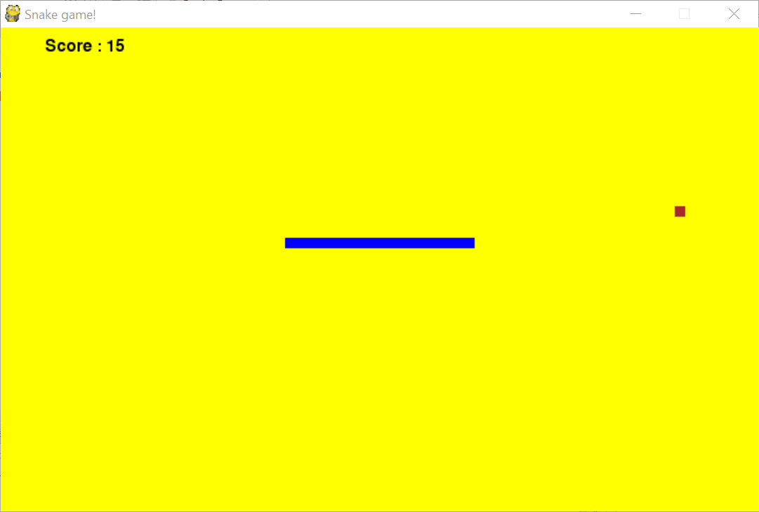

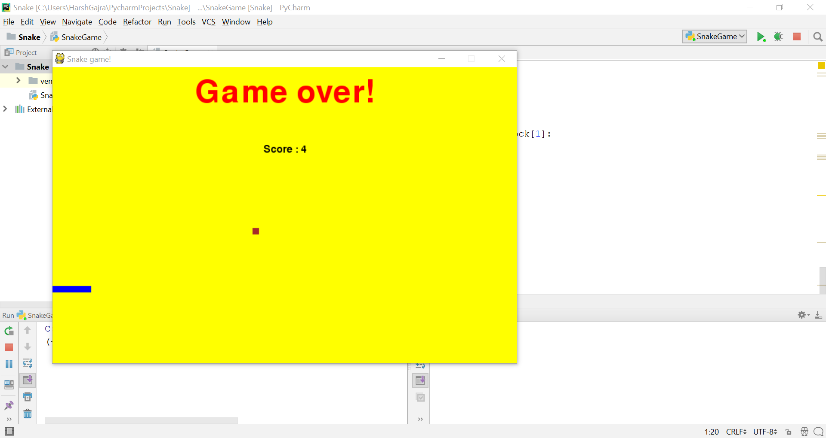

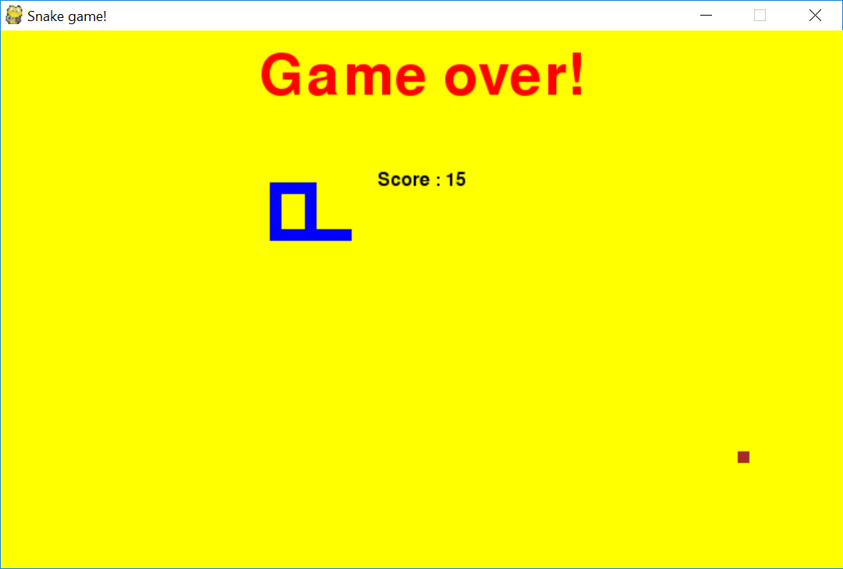

**Conclusion**- This project helped me understand how to use python to develop games as I was new to the world of python programming. Using pygame module I also learnt how to develop graphics for the game.

There is lot to be explored in the world of python based game development and it seems a interesting field.